UrbanWind Technologies
Risk Assessment Document
Date: July 18, 2024

1. Executive Summary

This risk assessment identifies and evaluates potential risks to UrbanWind Technologies' operations, financial stability, and market position. It provides a framework for understanding and mitigating these risks to ensure the company's continued growth and success in the urban wind energy market.

2. Risk Identification and Assessment Matrix

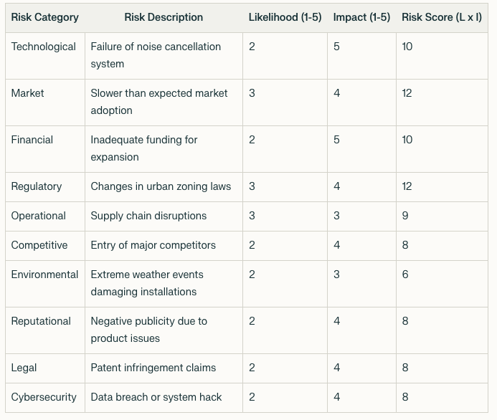

Likelihood and Impact are rated on a scale of 1 (Very Low) to 5 (Very High)
Risk Score = Likelihood x Impact

3. Detailed Risk Analysis and Mitigation Strategies

3.1 Technological Risks

Risk: Failure of noise cancellation system
Mitigation Strategies:
- Conduct rigorous testing in various environmental conditions
- Implement redundant noise cancellation systems
- Establish a rapid response team for immediate troubleshooting
- Continuously update and improve noise cancellation algorithms

3.2 Market Risks

Risk: Slower than expected market adoption
Mitigation Strategies:
- Intensify marketing efforts and customer education programs
- Offer trial periods or money-back guarantees
- Develop partnerships with urban developers and city planners
- Diversify product line to appeal to a broader market

3.3 Financial Risks

Risk: Inadequate funding for expansion
Mitigation Strategies:
- Maintain strong relationships with current investors
- Explore additional funding sources (e.g., grants, strategic partnerships)
- Implement strict financial controls and regular audits
- Develop contingency plans for various funding scenarios

3.4 Regulatory Risks

Risk: Changes in urban zoning laws
Mitigation Strategies:
- Engage proactively with local governments and regulatory bodies
- Stay informed about potential regulatory changes
- Participate in industry associations to influence policy
- Design products with adaptability to various regulatory requirements

3.5 Operational Risks

Risk: Supply chain disruptions
Mitigation Strategies:
- Diversify supplier base
- Maintain buffer inventory of critical components
- Develop contingency plans for alternative sourcing
- Implement real-time supply chain monitoring systems

3.6 Competitive Risks

Risk: Entry of major competitors
Mitigation Strategies:
- Continuously innovate and improve product offerings
- Strengthen patent portfolio and protect intellectual property
- Build strong brand loyalty through excellent customer service
- Explore strategic partnerships or acquisitions

3.7 Environmental Risks

Risk: Extreme weather events damaging installations
Mitigation Strategies:
- Enhance product durability and weather resistance
- Provide clear guidelines for operation in extreme conditions
- Offer comprehensive warranty and rapid repair services
- Collaborate with insurance providers for customer protection

3.8 Reputational Risks

Risk: Negative publicity due to product issues
Mitigation Strategies:
- Implement strict quality control measures
- Establish a proactive public relations strategy
- Maintain transparency in communications with stakeholders
- Develop a crisis management plan

3.9 Legal Risks

Risk: Patent infringement claims
Mitigation Strategies:
- Conduct regular patent landscape analyses
- Maintain a strong legal team specializing in intellectual property
- Consider cross-licensing agreements with potential competitors
- Set aside funds for potential legal defenses

3.10 Cybersecurity Risks

Risk: Data breach or system hack
Mitigation Strategies:
- Implement robust cybersecurity measures and regular audits
- Provide ongoing cybersecurity training for all employees
- Develop an incident response plan for potential breaches
- Ensure compliance with data protection regulations

4. Risk Monitoring and Review

- Establish a Risk Management Committee to oversee risk mitigation efforts
- Conduct quarterly reviews of the risk landscape and mitigation strategies
- Implement key risk indicators (KRIs) for early warning of emerging risks
- Integrate risk management into strategic planning and decision-making processes

5. Conclusion

While UrbanWind Technologies faces various risks, many of these are manageable with proper strategies and oversight. The company's innovative technology and strong market position provide a solid foundation for addressing these challenges. Continuous monitoring and adaptive management will be key to navigating the evolving risk landscape in the urban wind energy sector.

---

This risk assessment document provides a comprehensive overview of potential risks facing UrbanWind Technologies, along with strategies for mitigation. It can serve as a valuable tool for management decision-making and strategic planning. The document can be updated regularly as new risks emerge or as the company's circumstances change.

